**Manarat International University**

Project for Software Development

Course_code: CSE-312

***Project name: Survey app***

Git-hub link: [Click here](https://github.com/mim48/SoftDev)

Teammates:

Mardia Reza

1846CSE00648

Sanjida Akhter

1846CSE00653

*Date of submission:- 22/02/2021*

**Project Description**

Programming Language: Java

Platform: PC (Windows)

Features:

Here, we are trying to build an apps for Computer, mainly for windows. This apps are using to create survey for your query. Generally, you can find so many survey website and apps.

But ours app will be easier and user friendly. And we will try to give some extra feature.

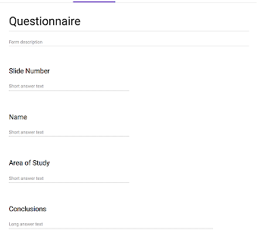

Contribution:

1. Sanjida: Create Idea, New features, Write code.
2. Mardia: Write code, update apps, fixing bugs, design apps.